ABSTRACT

The project titled “E-FERTILIZER RECOMMENDATION OVER WEB WITH PROCUREMENT ASSISTANCE PORTAL” is designed by using PHP as front end and MS SQL Server as back end.
In current system there is no portal that offers both the agriculture assistance information’s and shopping of fertilizers, insecticides and pesticides online. Farmers need to manually search for information in various site and need to shop in local store. So a new combined and informative website is needed.
This project assist’s farmers in agricultural cultivation by providing information about fertilizer, insecticides and pesticides. This website provides detailed information about fertilizers required for crop, implementation instruction, dosages and benefits.
This site also allows farmer’s to search and buy fertilizers, insecticides and pesticides according to their requirements. To avail this feature admin of the website, login’s to the site and posts information about fertilizers and pricing details. Farmers need to register their details in this website with the information such as name, address, contact number and email id. Only after the proper registration they can able to order required fertilizers for their desired location. In addition they can view the status of shipment whenever it’s necessary.
INTRODUCTION
India is an agrarian nation. But creating a profitable yield for the farmer in each crop cycle is becoming a major challenge on various factors. Picking the reasonable fertilizer for the land and yield is an important and basic part of agriculture. Deciding the supplement levels in soil utilizing lab hardware can be restrictively costly, particularly in developing nations. The current frameworks on deciding soil nutrient substance and proposal for fertilizer isn't sufficiently proficient efficient enough. This project introduces a compelling technique for estimation of nutrient dimension in soil and suggestion for appropriate fertilizer. The proposed methodologies comprise of four stages: soil analysis, data pre-processing, data analysis and Recommendation.
The proposed system aims to estimate the nutrient content and recommend the suitable fertilizer to be used for higher productivity. Under application of fertilizer results in low yield due to insufficient nutrients present in the soil for the crop. Over usage of fertilizer results in soil pollution. The food products from the polluted soil will be food poisoning and health issues for the consumers.

SYSTEM SPECIFICATION

HARDWARE REQUIREMENTS
This section gives the details and specification of the hardware on which the system is expected to work.
Processor : Intel I3
RAM : 8 GB RAM
Monitor : 17” Color
Hard disk : 1TB
Keyboard : Standard102 keys
Mouse : LOGI TECH (3 Buttons)

SOFTWARE REQUIREMENTS
This section gives the details of the software that are used for the development.

Front-End : PHP 5.4
Back-End : My-SQL 5.6
Operating System : Windows 10

SOFTWARE DESCRIPTION
FRONT END
HTML
HTML or Hypertext Markup Language is the main markup language creating Webpage and other information that can be displayed in the web browser. HTML5.1 is the latest standard for HTML. It was specially designed to deliver a rich content without the need for additional plug-in. The current version delivers everything from animation to graphics and also be used to build complicated web application. HTML 5.1 is also cross – platform. It is designed to work whether the people are using a PC, or a Tablet, a Smartphone.
Some rules for HTML were established:
- New feature should be based on HTML, CSS, JavaScript.
- The need for external plug – in (like flash) should be reduced.
- Error handling should be easier the in previous version.
- Scripting has to be replaced by some mark-up.
- HTML 5.1 should be device independent
- The development process should be visible to public.

Features of HTML5
- The <canvas>element is used to allow a web developer to render graphics on the fly. As with video, there is no need for a plug-in.
- Web Workers is certain web application use heavy
- Scripts to perform function. Web Workers use separate background threads for processing.
- Application caches is used to Web pages will start storing more and more information locally on the visitors computer.it works like cookies, but where cookies are small ,the new feature allows larger files.
- Geo location is best known for use on mobile devices, geo location is coming with HTML5.
- Support for local storage.
- New form controls, like calendar, date, time, email, URL search.
- New content-specific element, like <article>, <footer>, <header>, <new>, <section>.
- The video and audio element for media playback.

CSS
CSS Stands for "Cascading Style Sheet". Cascading style sheets are used to format the layout of Web pages. They can be used to define text styles, table sizes, and other aspects of web pages that previously could only be defined in a page's HTML. CSS helps Web developers create a uniform look across several pages of a Web site. Instead of defining the style of each table and each block of text within a page's HTML, commonly used styles need to be defined only once in a CSS document. Once the style is defined in cascading style sheet, it can be used by any page that references the CSS file. Plus, CSS makes it easy to change styles across several pages at once. For example, a Web developer may want to increase the default text size from 10pt to 12pt for fifty pages of a Web site. If the pages all reference the same style sheet, the text size only needs to be changed on the style sheet and all the pages will show the larger text.

JAVASCRIPT
JavaScript is a programming language commonly used in web development. It was originally developed by Netscape as a means to add dynamic and interactive elements to websites. While JavaScript is influenced by Java, the syntax is more similar to C and is based on ECMA Script, a scripting language developed by Sun Microsystems.
JavaScript is a client-side scripting language, which means the source code is processed by the client's web browser rather than on the web server. This means JavaScript functions can run after a webpage has loaded without communicating with the server. For example, a JavaScript function may check a web form before it is submitted to make sure all the required fields have been filled out. The JavaScript code can produce an error message before any information is actually transmitted to the server.

PHP
PHP (Hypertext Pre Processor) is a popularly used server side scripting language that is basically designed for the web development to produce dynamic web pages.
PHP code is interpreted by a web server with a PHP processor module, which generates the resulting Web Pages. PHP commands can be embedded directly into an HTML sources document rather than calling an external file to process data. It has also evolved to include a commend line interface capability and can be used in standalone graphical applications.
Advantages of PHP
- PHP provides a more secured website due to high quality encryption scheme.
- PHP applications provide a fast browsing experience due to the reason that all the processing is performed at the server side.
- PHP is freely available which helps to cut the cost of development to a considerable extent.
- It provides compatibility with almost every web server and operating system the application is laid on.
- The load of PHP developed sites is also less as PHP is a light weighted language for web-site development.

Features of PHP
- It is general purpose open-source language
- It is extremely user-friendly as compared to other popular languages.
- PHP is taken as a unique language supporting various functions.
- PHP can manage a lot of database.
- PHP s flexible. It runs on different operating systems.
BACK END
DATABASE My-SQL
MySQL is an open source relational database management system, which can be available any time. It has no cost for development purpose. A database is a separate application that stores a collection of data. Each database has one more distinct APIs for creating, accessing, managing, searching and replicating data it holds. Its name is a combination of “My”, the name of co-founder “Michael Widenius’ daughter, and “SQL”, the abbreviation for structures Query Language. MySQL is written in C and C++.Its SQL parser is written in yacc, but it uses a home-brewed lexical analyser. MySQL works on many system platforms, including AIX, BSDI, FREEBSC, HP-UX, EComStation, i5/OS, IRIX, Linux, OSX Microsoft windows NetBSD, Novell Netware, OpenBSD, Open Solaris, OS/2, Warp, QNX,Oracle Solaris, Symbian, SunOS, SCO Open server, SCO UnixWare, Sanos and Tru64.A port of MySQL to open VMS also exists.
The MySQL server software itself and the client libraries use dual-licensing distribution. They are offered under GPL version 2, beginning from 28 June 2000(Which in2009 has been extended with a FLOSS License Exception) or to use a proprietary license.
Support can be obtained from the official manual. Free support additionally is available in different IRC channels and forums. Oracle offers paid support via its MySQL Enterprise products. They differ in the scope of services and in price. Additionally, a number of third party organizations exist to provide it “performs extremely well in the average case” and that the “developer interface are there, and the documentation is very, very good”. It has also been tested to be a “fast, stable and true multi-user, multi-threaded SQL database server”.

FEATURES
MySQL is offered fewer than two different editions: the open source MySQL Community Server and the proprietary Enterprise Server.
MySQL enterprise server is differentiated by a series of proprietary extensions which install as server pug-in, but otherwise shares the version numbering system and is built from the same code base.

Major features as available in MySQL:
- A broad subset of ANSI SQL 99,as well as extension
- Cross-platform support
- Stored procedures, using a procedural language that closely adheres to SQL/PSM
- Triggers
- Online DDL when using the InnoDB Storage Engine.
- Information schema
- Performance Schema that collects and aggregates statistics about server execution and query performance for monitoring purpose.
- A set of SQL Mode options to control runtime behaviour, including a strict mode to better adhere to SQL standards.
- X/Open XA distributed transaction processing (DTP) support; two phase commit as part of this, using the default InnoDB storage engine.
- Transactions with save points when using the default InnoDB Storage Engine. The NDB Cluster Storage Engine also supports transactions.
- ACID compliance when using InnoDB and NDB Cluster Storage Engines.
- SSL supports.
- Query caching.
- Sub-SELECTs
- Full-text indexing and searching.
- Embedded database library.
ADVANTAGES OF USING MySQL
- It’s Easy To Use
MySQL is very easy to install, and thanks to a bevy of third-party tools that can be added to the database, setting up an implementation is relatively simple task. In addition, it’s also an easy database to work with. So long as you understand the language, you should not run into too many problems.
- Supports Is Readily Available Whenever Necessary
Although Oracles history of supporting its customers can be spotty at best, the nature of MySQL – which got its start as an open-source platform-means that there’s large and thriving community of developers and enthusiasts to which one can turn for help. This is due in large part to the popularity of the solution, the end results of which is no shortage of experts.
- It’s Open-Source
Oracle’s purchase of Sun Microsystem was met with some contention from the development community. The general fear was that Oracle would transform the tool into a closed, proprietary ecosystem.

SYSTEM ANALYSIS

EXISTING SYSTEM
The existing system is offline. At present farmer is not aware of agriculture fertilizer usages information. And also fertilizer shop finds difficult in reaching their product to farmers. So there rise the need for a proposed system to rectify the drawbacks of the existing system and so it is computerized.

DRAWBACKS OF EXISTING SYSTEM
- Poor Availability of Information.
- High Barrier For farmer Involvement.
- Farmers find difficult in buying required fertilizers.
- Difficult for shop to maintain stock details offline.
- Reaching customer over online becomes difficult.
- Transaction report generation is difficult.
PROPOSED SYSTEM
The proposed systems provide a single point of access to a variety of content and services of the help information provision, and ideally work process. The new system handles data in a centralized manner and eases the data access from various locations since the system is web oriented.

ADVANTAGES OF PROPOSED SYSTEM
- Help-specific information can be retrieved.
- Customized views to the farmers as well as administrator.
- Effective communication between administrator and farmers.
- Information can be accessed from anywhere over the world.
- Easy for shop to promote their products online.
- Transaction report generation becomes easier.

FEASIBILITY STUDY
The feasibility study deals with all the analysis that takes up in developing the project. Each structure has to be thought of in the developing of the project, as it has to serve the end user in a user-friendly manner. One must know the type of information to be gathered and the system analysis consist of collecting, Organizing and evaluating facts about a system and its environment.

Three considerations involved in feasibility analysis are

ECONOMICAL FEASIBILITY
    - OPERATIONAL FEASIBILITY
    - TECHNICAL FEASIBILITY

ECONOMIC FEASIBILITY
The organization has to buy a personal computer with a keyboard and a mouse, this is a direct cost. There are many direct benefits of covering the manual system to computerized system. The user can be given responses on asking questions, justification of any capital outlay is that it will reduce expenditure or improve the quality of service to the user. The users who have basic knowledge about Microsoft technologies can use this service by accessing the service provided in the web site.

OPERATIONAL FEASIBILITY
The Proposed system accessing process to solves problems what occurred in existing system. The current day-to-day operations of the organization can be fit into this system. Mainly operational feasibility should include on analysis of how the proposed system will affects the organizational structures and procedures.
The proposed system requires less human interaction and anybody who has the basic computer devices can access these services and operate on their needed part of the services to get the services that are needed by the user.
TECHNICAL FEASIBILITY
The cost and benefit analysis may be concluded that computerized system is favorable in today’s fast moving world. The assessment of technical feasibility must be based on an outline design of the system requirements in terms of input, output, files, programs and procedure.
The project aims to provide the faster information sharing using the web application and to reduce the difficulties involved in request handling that are given by users of the website. The current system aims to overcome the problems of the existing system. The current system is to reduce the technical skill requirements so that more number of users can access the application
SYSTEM DESIGN AND DEVELOPMENT
INPUT DESIGN
Input design is the process of converting user-originated inputs to a computer understandable format. Input design is one of the most expensive phases of the operation of computerized system and is often the major problem of a system. A large number of problems with a system can usually be tracked backs to fault input design and method. Every moment of input design should be analyzed and designed with utmost care.

The design of the input should be made the input as the over to the numerous networks in the reliable area that should be passed as the installation in the remote network. It has the following constraints in the input database.

- All the files from the disk should be acquired by data.
- It is suitable to more available data clearance and made available.
- The menu of design should be understandable and it is in the right format.

The system takes input from the users, processes it and produces an output. Input design is link that ties the information system into the world of its users. The system should be user-friendly to gain appropriate information to the user. The decisions made during the input design are the project gives the low time consumption to make the sensitive application made simple. When applying the project it provides the low man-power attrition with the reasonable output.

The amount of fund that the company can spend into the research and development of the system is limited. The expenditures must be justified. Thus the developed system as well within the budget and this was achieved because most of the technologies used are freely available. Only the customized products had to be purchased.

Input data of a system may not be necessarily is raw data captured in the system from scratch. These can also be the output of another system or subsystem. The design of input covers all the phases of input from the creation of initial data to actual entering of the data to the system for processing. The design of inputs involves identifying the data needed, specifying the characteristics of each data item, capturing and preparing data fro computer processing and ensuring correctness of data.

Input design is the process of converting user-originated inputs to a computer-based format. Input design is one of the most expensive phases of the operation of computerized system and is often the major problem of a system.

Any Ambiguity in input leads to a total fault in output. The goal of designing the input data is to make data entry as easy and error free as possible.

In the project, the forms are designed with easy to use options such as selecting the master records through dropdown list in transaction forms. The coding is being done such that proper validations are made to get the perfect input. No error inputs are accepted. The end users need not to give the id themselves.

OUTPUT DESIGN
Output design generally refers to the results and information that are generated by the system for many end-users; it should be understandable with the enhanced format.

The Output of the software is used to make the remote installation of the new software in the system and, it is awake the immediate alert to the system that should be enhanced it as the input to the system. Output is the main reason for developing the system and the basis on which they evaluate the usefulness of the application.

Computer output is the most important direct source of information to the user output design deals with form design efficient output design should improve the interfacing with user.

The term output applies to any information produced by an information system in terms of displayed. When analyst design system output, they Identify the specific output that is needed to meet the requirements of end user. Previewing the output reports by the user is extremely important because the user is the ultimate judge of the quality of the output and, in turn, the success of the system

When designing output, system analysis accomplishes more things like, to determine what applications, websites or documents whether blocked or allowed. Allowing should be in various options. The output is designed in such a way that it is attractive, convenient and informative.

Forms are designed in VB.NET with various features, which make the console output more pleasing. As the outputs are the most important sources of information to the users, better design should improve the system’s relationships with user and also will help in decision-making. Form design elaborates the way output is presented and the layout available for capturing information.
DATABASE DESIGN
The most important consideration in designing the database is how information will be used. The main objectives of designing a database are:

Data Integration

In a database, information from several files are coordinated, accessed and operated upon as through it is in a single file. Logically, the information are centralized, physically, the data may be located on different devices, connected through data communication facilities.

Data Integrity
Data integrity means storing all data in one place only and how each application to access it. This approach results in more consistent information, one update being sufficient to achieve a new record status for all applications, which use it. This leads to less data redundancy; data items need not be duplicated; a reduction in the direct access storage requirement.

Data Independence

Data independence is the insulation of application programs from changing aspects of physical data organization. This objective seeks to allow changes in the content and organization of physical data without reprogramming of applications and to allow modifications to application programs without reorganizing the physical data.

The tables needed for each module were designed and the specification of each and every column was given based on the records and details collected during record specification of the system study.

TABLE STRUCTURE
Table Name : Login Table
Description : This table is used to maintain admin login details.
FIELD NAME | DATA TYPE | SIZE | CONSTRAINTS
Username | Varchar | 15 | Primary key
Password | Varchar | 15 | Not Null

Table Name : Supplier Table
Description : This table is used to maintain supplier details.
FIELD NAME | DATA TYPE | SIZE | CONSTRAINTS
SupplierId | Varchar | 50 | Primary key
SupplierName | Varchar | 50 | Not Null
CompanyName | Varchar | 20 | Not Null
Address | Varchar | 250 | Not Null
ContactNo | Varchar | 10 | Not Null
EmailId | Varchar | 50 | Not Null

Table Name : User Table
Description : This table is used to maintain user details.
FIELD NAME | DATA TYPE | SIZE | CONSTRAINTS
UserId | Varchar | 10 | Primary key
UserName | Varchar | 50 | Not Null
Address | Varchar | 500 | Not Null
District | Varchar | 50 | Not Null
ContactNo | Varchar | 10 | Not Null
EmailId | Varchar | 50 | Not Null
Password | Varchar | 20 | Not Null

Table Name : Stock Table
Description : This table is used to maintain stock details.
FIELD NAME | DATA TYPE | SIZE | CONSTRAINTS
ProductId | Varchar | 10 | Primary key
ProductName | Varchar | 50 | Not Null
ForCrop | Varchar | 500 | Not Null
HowToUse | Varchar | 500 | Not Null
Benefits | Varchar | 500 | Not Null
Unit | Varchar | 20 | Not Null
Purchase Price | Decimal | 18,2 | Not Null
Tax | Float | 4 | Not Null
Selling Price | Decimal | 18,2 | Not Null
Quantity | Decimal | 9,1 | Not Null
ReorderLevel | Int | 11 | Not Null
ExpiryDate | Date | 9 | Not Null
Image | Varchar | 50 | Not Null

Table Name : Cart Table
Description : This table is used to maintain cart details.
FIELD NAME | DATA TYPE | SIZE | CONSTRAINTS
Sno | Int | 4 | Primary key
UserId | Varchar | 10 | Not Null
ProductId | Varchar | 10 | Not Null
ProductName | Varchar | 50 | Not Null
Price | Float | 4 | Not Null
Quantity | Float | 4 | Not Null
Total | Float | 4 | Not Null

Table Name : Purchase Table
Description : This table is used to maintain purchase details.
FIELD NAME | DATA TYPE | SIZE | CONSTRAINTS
InvoiceNo | Varchar | 10 | Primary key
SupplierId | Varchar | 10 | Not Null
ProductId | Varchar | 10 | Not Null
PurchasePrice | Decimal | 18,2 | Not Null
Tax | Float | 4 | Not Null
Quantity | Decimal | 18,1 | Not Null
Total | Decimal | 18,2 | Not Null

Table Name : Sale Master
Description : This table is used to maintain sale master details.
FIELD NAME | DATA TYPE | SIZE | CONSTRAINTS
InvoiceNo | Int | 11 | Primary key
UserId | Varchar | 50 | Not Null
UserName | Varchar | 50 | Not Null
InvoiceDate | Date | 9 | Not Null
Quantity | Int | 2 | Not Null
Total | Decimal | 8,2 | Not Null
Status | Varchar | 10 | Not Null

Table Name : Sale Trans
Description : This table is used to maintain sale trans details.
FIELD NAME | DATA TYPE | SIZE | CONSTRAINTS
Sno | Int | 11 | Primary key
InvoiceNo | Int | 11 | Not Null
ProductId | Varchar | 20 | Not Null
ProductName | Varchar | 50 | Not Null
Price | Decimal | 8,2 | Not Null
Quantity | Float | 4 | Not Null
Total | Decimal | 8,2 | Not Null
SYSTEM DEVELOPMENT
MODULE DESCRIPTION
The project contains following modules,
- ADMIN LOGIN
- SUPPLIER ENTRY
- POST FERTILIZER DETAILS
- PURCHASE INVOICE ENTRY
- PRICE UPDATION
- PURCHASE INVOICE
- VIEW/REPLY QUERY
- INVOICE LIST
- CUSTOMER REGISTRATION
- SEARCH PRODUCT
- FERTILIZER RECOMMENDATION
- ADD TO CART
- ORDER PROCESSING
- MY ORDERS BY CUSTOMER
- DELIVERED ORDER REPORT
- PROFILE UPDATION
- ADD QUERY
- VIEW REPLY
- CUSTOMER REPORT
- SUPPLIER REPORT
- FORGET PASSWORD
SUPPLIER ENTRY
This module is used for storing the supplier information. The details such as supplier is, company name, address, contact no, email id are stored in the table. These details are stored in the appropriate with the help of sql server.

USER LIST
The customer details are one of the vital information that has to be maintained by every business management, because customer satisfaction and customer relationships are the main objectives that need to be achieved for better quality of service. In this module admin views all the information about the registered customer details.

PRODUCT CREATION
In this module admin creates new product for sales. This product includes the information such as product id, name, purchase price, tax, selling price, rating and available stock. These details are store in database.

SUPPLIER REPORT
In this module admin views all the information about the saved supplier details. This includes the information such as supplier id, name, address, and contact no and email id. This information is fetched from the database.

STOCK REPORT
In this module admin views the current stock availability and product information. This includes the information such as product id, name, purchase price, tax, selling price and rating. This information is fetched from the database.

VIEW/REPLY QUERY
In this module admin views the query from customers and can reply the answer to corresponding customer. The query details are stored in query table present in database.

PRICE UPDATION
In this module admin updates prices for each and every stock available. These details are updated in database with the help of MySQL

PURCHASE INVOICE
In this module admin increases the product stock by purchasing the stock from the supplier. This includes the information such as seller id, product id, name, and category, purchase price, selling price, quantity and total.

INVOICE LIST
In this module admin views the purchase invoice list. This includes the information such as seller id, purchase value, tax value, quantity and total value.

ORDER PROCESSING
In this module customer orders are processed by admin. Admin delivers or rejects the customer’s order after verifying the stock details. After the order has been processed the status will be mailed to the customer.

DELIVERED ORDER REPORT
This module is used for viewing the delivered and rejected customer orders. Admin can use this information for taxation submission process.

REGISTRATION
In this module customer register their details into the website so as make the order. This details includes the information such as customer id, name, address, contact no, email id and payment information.

FERTILIZER RECOMMENDATION
This module recommends fertilizers based on the disease available in plant so that user can know about the pesticides, insecticides and fertilizers

SEARCH PRODUCT
In this module customer searches for the product using the key words. This result includes the information such as product id, name, and tax, selling price, available stock and description. This information is fetched from the database.
ADD TO CART
In this module customer adds the wished product to the cart by entering the required quantity and proceeding. The cart can be modified at any time till the order placement.
MY ORDERS
In this module customer tracks the order status by entering the order no and check status. This will be used as a future reference for the invoice list of purchased product details.

ADD QUERY
In this module the customer can raise the questions to the admin if any additional information required.

VIEW QUERY
In this module the customers are allowed to view the reply from the admin for corresponding queries raised by the customer.

PROFILE UPDATION
In this module customer updates their profile details such as name, address, city, contact no and email id. These details are saved in database with the help of MySQL.

FORGET PASSWORD
In case of forgetting the profile password, an option is available to recover the unknown password. This feature will mail the password to the registered mail id, thus helps user to recover the account.
SYSTEM TESTING

After the source code has been completed, documented as related data structures. Completed the project has to undergo testing and validation where there is subtitle and definite attempt to get errors.

The project developer treads lightly, designing and execution test that will demonstrates that the program works rather than uncovering errors, unfortunately errors will be present and if the project developer doesn’t find them, the user will find out.

The project developer is always responsible for testing the individual units i.e. modules of the program. In many cases developer also conducts integration testing i.e. the testing step that leads to the construction of the complete program structure.

This project has undergone the following testing procedures to ensure its correctness.
- Unit testing
- User Acceptance Testing

UNIT TESTING
In unit testing, we have to test the programs making up the system. For this reason, Unit testing sometimes called as Program testing. The software units in a system are the modules and routines that are assembled and integrated to perform a specific function, Unit testing first on the modules independently of one another, to locate errors. This enables, to detect errors in coding and logic that are contained with the module alone. The testing was carried out during programming stage itself.

USER ACCEPTANCE TESTING
In these testing procedures the project is given to the customer to test whether all requirements have been fulfilled and after the user is fully satisfied. The project is perfectly ready. If the user makes request for any change and if they found any errors those all errors has to be taken into consideration and to be correct it to make a project a perfect project.

INTEGRATION TESTING
Integration testing is done to test if the individual modules work together as one single unit. In integration testing, the individual modules that are to be integrated are available for testing. Thus the manual test data that used to test the interfaces replaced by that which in generated automatically from the various modules. It can be used for testing how the modules would actually interact with the proposed system. The modules are integrated and tested to reveal the problem interfaces.

SYSTEM IMPLEMENTATION

When the initial design was done for the system, the client was consulted for the acceptance of the design so that further proceedings of the system development can be carried on. After the development of the system a demonstration was given to them about the working of the system. The aim of the system illustration was to identify any malfunction of the system.

After the management of the system was approved the system implemented in the concern, initially the system was run parallel with existing manual system. The system has been tested with live data and has proved to be error free and user friendly.

Implementation is the process of converting a new or revised system design into an operational one when the initial design was done by the system; a demonstration was given to the end user about the working system.

This process is uses to verify and identify any logical mess working of the system by feeding various combinations of test data. After the approval of the system by both end user and management the system was implemented. System implementation is made up of many activities. The six major activities are as follows.

CODING
Coding is the process of whereby the physical design specifications created by the analysis team turned into working computer code by the programming team.

TESTING
Once the coding process is begin and proceed in parallel, as each program module can be tested.

INSTALLATION
Installation is the process during which the current system is replaced by the new system. This includes conversion of existing data, software, and documentation and work procedures to those consistent with the new system.

DOCUMENTATION
It is result from the installation process, user guides provides the information of how the use the system and its flow.

TRAINING AND SUPPORT
Training plan is a strategy for training user so they quickly learn to the new system. The development of the training plan probably began earlier in the project.
.

CONCLUSION AND FUTURE ENHANCEMENTS

CONCLUSION
Thus this project helps farmers to know about fertilizer, pesticide and insecticide information. It also allows better communication between shop owner and farmers. Thus helps in buying fertilizers online. The web application is tested well and end users satisfaction is found to be more. The application is designed such that minimum internet knowledge is required for end users to browse the web site.

SCOPE FOR FUTURE DEVELOPMENT
Future of this project can be easily updated. To achieve the benefits that expected from the user must understand the overall system and they must be able to carry out their specific tasks effectively. The successful implementation depends upon the right people at the right time.

The application become useful if the below enhancements are made in future.
- If the application is designed as web service, it can be integrated in many web sites.
- If more information is give, more useful
The application is developed such that above said enhancements can be integrated with current modules.
BIBLIOGRAPHY

BOOK REFERENCES
- The Joy of PHP Programming: A Beginner’s Guide – by Alan Forbes
- PHP & MySQL Novice to Ninja – by Kevin Yank
- Head First PHP & MySQL – by Lynn Beighley & Michael Morrison
- Learning PHP, MySQL, JavaScript, and CSS: A Step-by-Step Guide to Creating Dynamic Websites – by Robin Nixon
- PHP & MySQL Web Development – by Luke Welling & Laura Thompson
- PHP & MySQL: The Missing Manual – by Brett McLaughlin
- PHP: A Beginner’s Guide – by Vikram Vaswani
- Learn PHP & MySQL – Zero to Hero Programming Crash Course – by Paul Madoff
- Murach’s PHP & MySQL – by Joel Murach & Ray Harris
- Programming PHP – by Kevin Tatroe, Peter MacIntyre & Rasmus Lerdorf “Foreword By: Michael Bourque”

WEB REFERENCES
- http://www.php.net/manual/en/language.references.php
- http://www.webreference.com
- www.phptherightway.com
- https://www.w3schools.com/php/
- zetcode.com/lang/php/functions

APPENDIX
SYSTEM FLOW DIAGRAM

E-FERTILIZER ASSISTANCE WITH SHOPPING PORTAL
ADMIN
USER
REGISTRATION
SUPPLIER ENTRY
PRODUCT CREATION
SUPPLIER REPORT
CUSTOMER REPORT
STOCK REPORT
SEARCH PRODUCT
ADD TO CART
MY ORDERS
ORDER PROCESSING
DELIVERS ORDERS
LOW STOCK INTIMATION
PROFILE UPDATION
FORGET PASSWORD
PURCHASE INVOICE
INVOICE REPORT

DATA FLOW DIAGRAM
LEVEL 0
WEB APPLICATION
Customer
Search Products
Make Order
Manage Products, Customer Orders
Add Products, Update Customer order, invoice maintenance
Admin
LEVEL 1

Login
Admin
Add or View Products and it Category
Process Orders & Approve
Maintain Suppliers
Stock
Purchase Master
Supplier
Login
User

User
Search Products
Add To Cart and Make Order
My Orders
Admin Table
Stock
Purchase and Update Stock
Sale Master
Sale Trans
Forget Password
User

SAMPLE CODING
REGISTRATION PAGE
<?php
include('Db.php');

$Id=$_POST["txtId"];
$Name=$_POST["txtName"];
$Address=$_POST["txtAddress"];
$District=$_POST["ddDistrict"];
$ContactNo=$_POST["txtContactNo"];
$MailId=$_POST["txtMailId"];
$Password=$_POST["txtPassword"];

$qry="Insert Into UserTable Values('". $Id ."','". $Name ."','". $Address ."','". $District ."','". $ContactNo ."','". $MailId ."','". $Password ."')";
mysql_query($qry,$con) or die(mysql_error());
header('location:Registration.php');
mysql_close($con);
?>
NEW PRODUCT

<?php
include('Db.php');

$Id=$_POST["txtId"];
$Name=$_POST["txtName"];
$Category=$_POST["ddCategory"];
$Unit=$_POST["ddUnit"];
$Description=$_POST["txtDescription"];
$ReOrderLevel=$_POST["txtReOrderLevel"];
$file_name = "";

if(isset($_FILES['fileUploader']))
{
$nameforExt = $_FILES['fileUploader']['name'];
$ext = pathinfo($nameforExt, PATHINFO_EXTENSION);

$file_name = $Id . '.' . $ext;
$file_tmp =$_FILES['fileUploader']['tmp_name'];
move_uploaded_file($file_tmp,"Image/Product/".$file_name);

}

$qry="Insert Into StockTable Values('". $Id ."','". $Name ."','". $Category ."','". $Unit ."',0,0,0,0,'". $ReOrderLevel ."','','". $file_name ."','". $Description ."')";
mysql_query($qry,$con) or die(mysql_error());
mysql_close($con);
header('location:AddProduct.php');
?>

PURCHASE INVOICE

<?php
include('Db.php');

$InvoiceNo=$_POST["txtInvoiceNo"];
$Supplier=$_POST["ddSupplier"];
$Product=$_POST["ddProduct"];
$ExpiryDate=$_POST["txtExpiryDate"];
$PurchasePrice=$_POST["txtPurchasePrice"];
$Tax=$_POST["txtTax"];
$SellingPrice=$_POST["txtSellingPrice"];
$Quantity=$_POST["txtQuantity"];
$Total=$_POST["txtTotal"];

$qry="Insert Into PurchaseTable Values('". $InvoiceNo ."','". $Supplier ."','". $Product ."','". $PurchasePrice ."','". $Tax ."','". $Quantity ."','". $Total ."')";
if(mysql_query($qry,$con))
{
$qry="Update StockTable Set Quantity = Quantity + '". $Quantity ."' Where ProductID = '". $Product ."' ";
mysql_query($qry,$con) or die(mysql_error());

$qry="Update StockTable Set PurchasePrice = '". $PurchasePrice ."' Where ProductID = '". $Product ."' ";
mysql_query($qry,$con) or die(mysql_error());

$qry="Update StockTable Set ExpiryDate = '". $ExpiryDate ."' Where ProductID = '". $Product ."' ";
mysql_query($qry,$con) or die(mysql_error());

$qry="Update StockTable Set Tax = '". $Tax ."' Where ProductID = '". $Product ."' ";
mysql_query($qry,$con) or die(mysql_error());

$qry="Update StockTable Set SellingPrice = '". $SellingPrice ."' Where ProductID = '". $Product ."' ";
mysql_query($qry,$con) or die(mysql_error());
}
else
{
die(mysql_error());
}
mysql_close($con);
header('location:AddPurchase.php');
?>

SAMPLE SCREENS

HOME PAGE
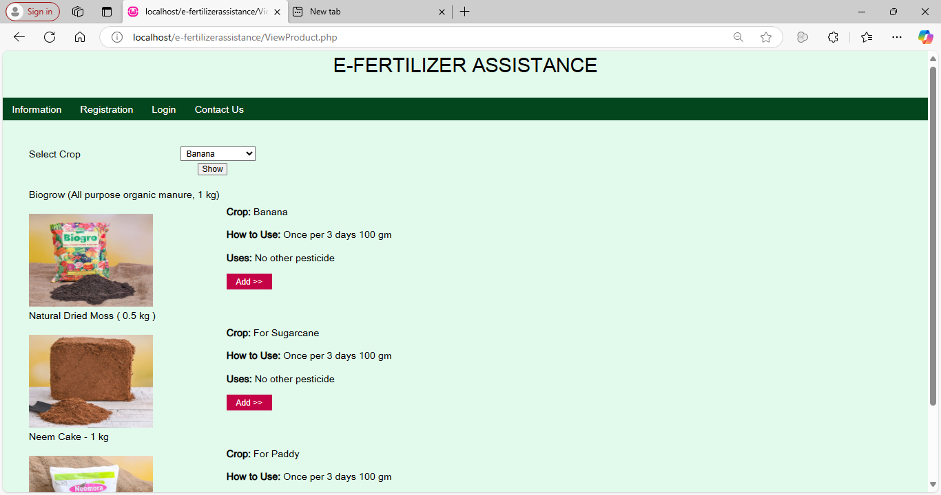
ADMIN LOGIN

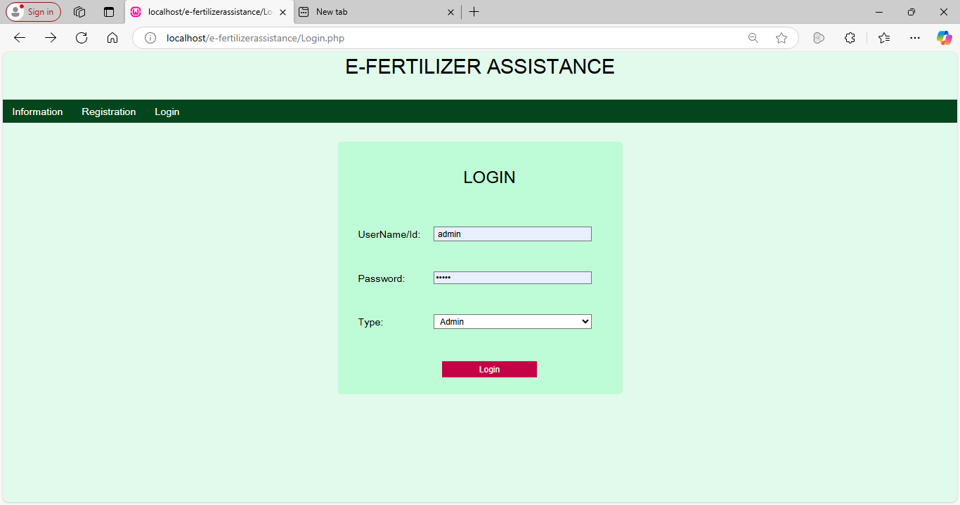
NEW SUPPLIER
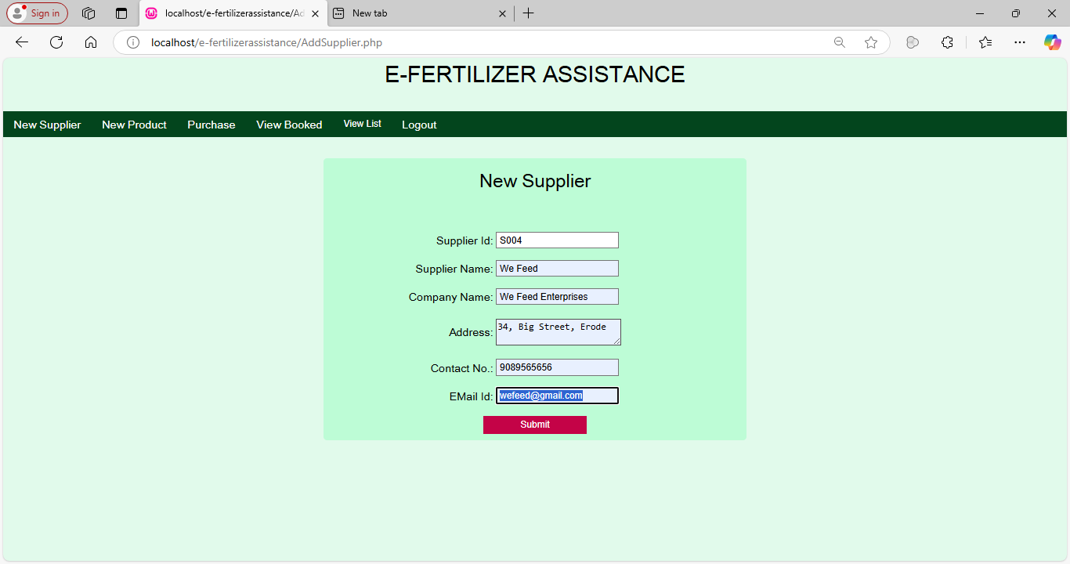
NEW PRODUCT
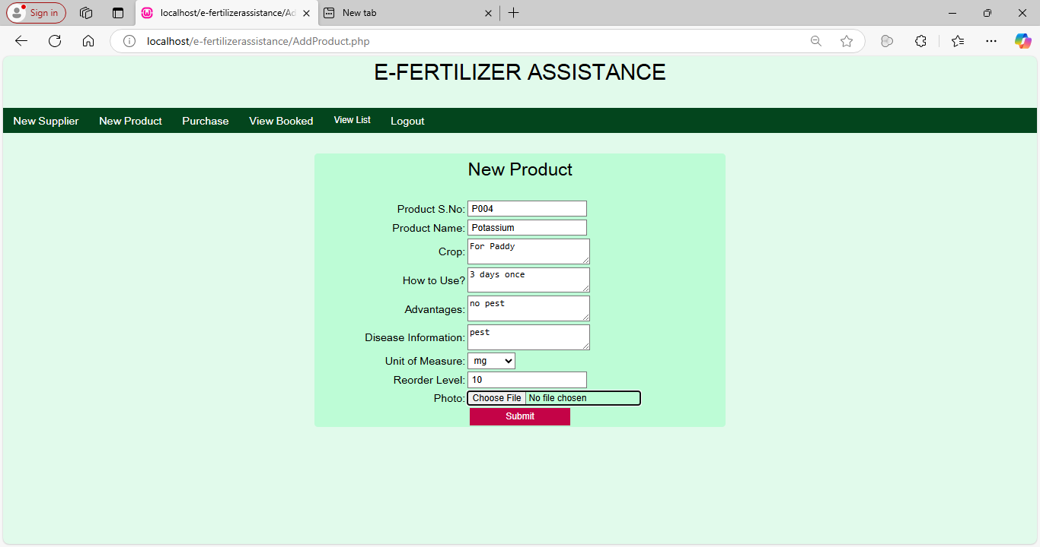
NEW PURCHASE
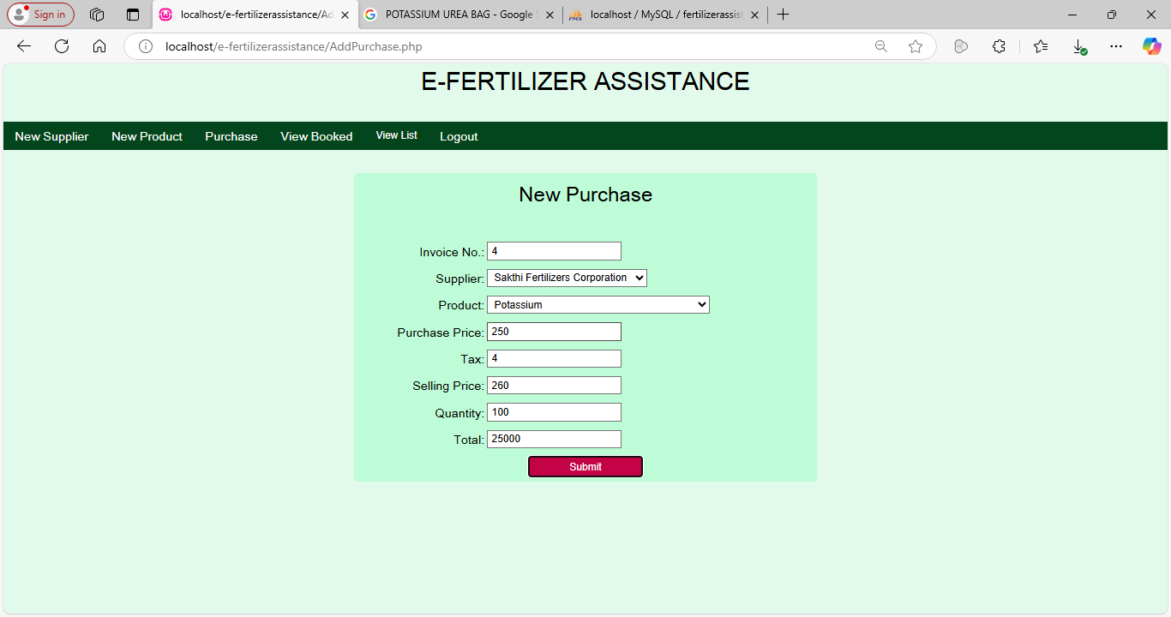
VIEW SUPPLIERS
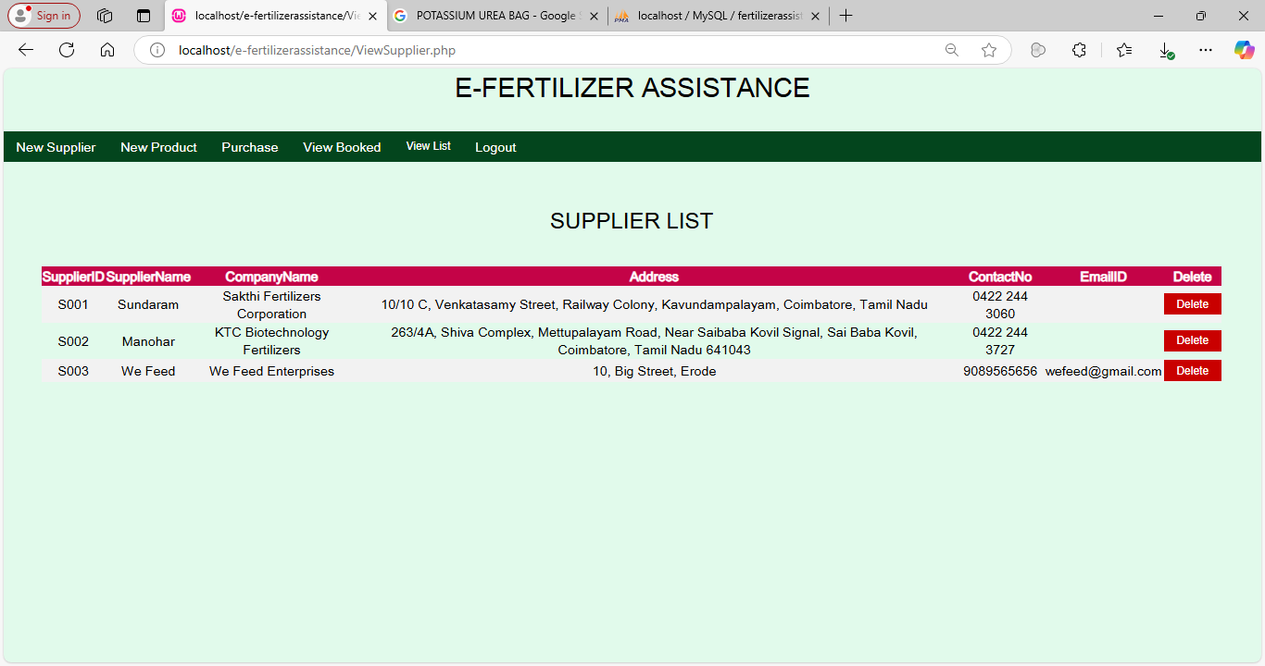
VIEW USERS

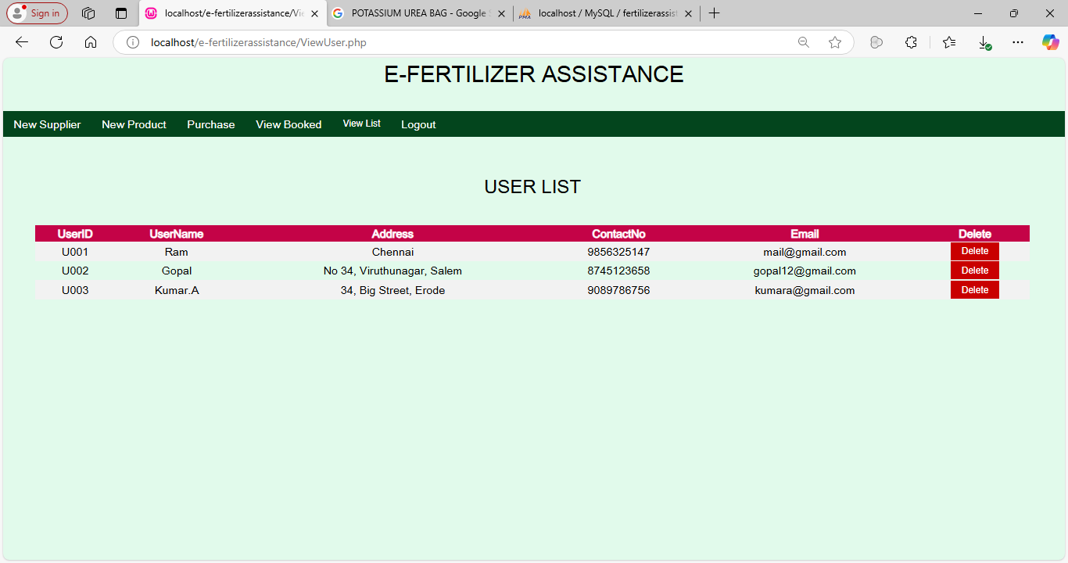
VIEW STOCK
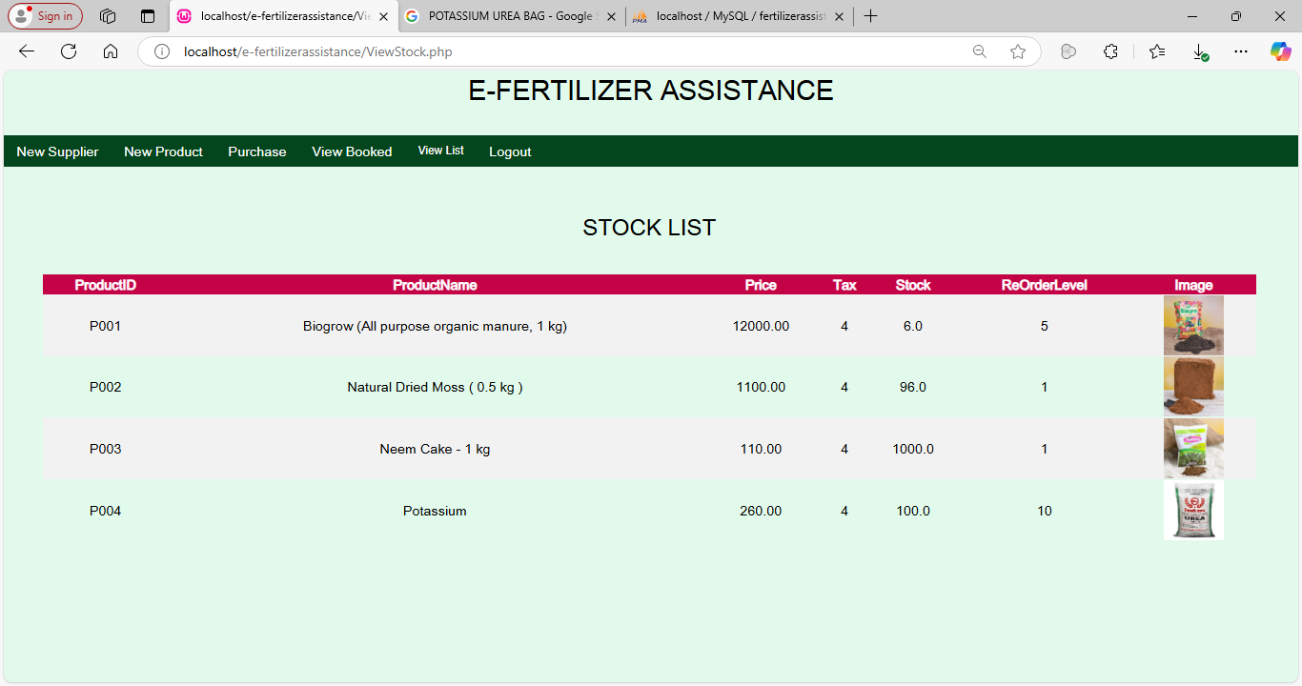
VIEW PURCHASE
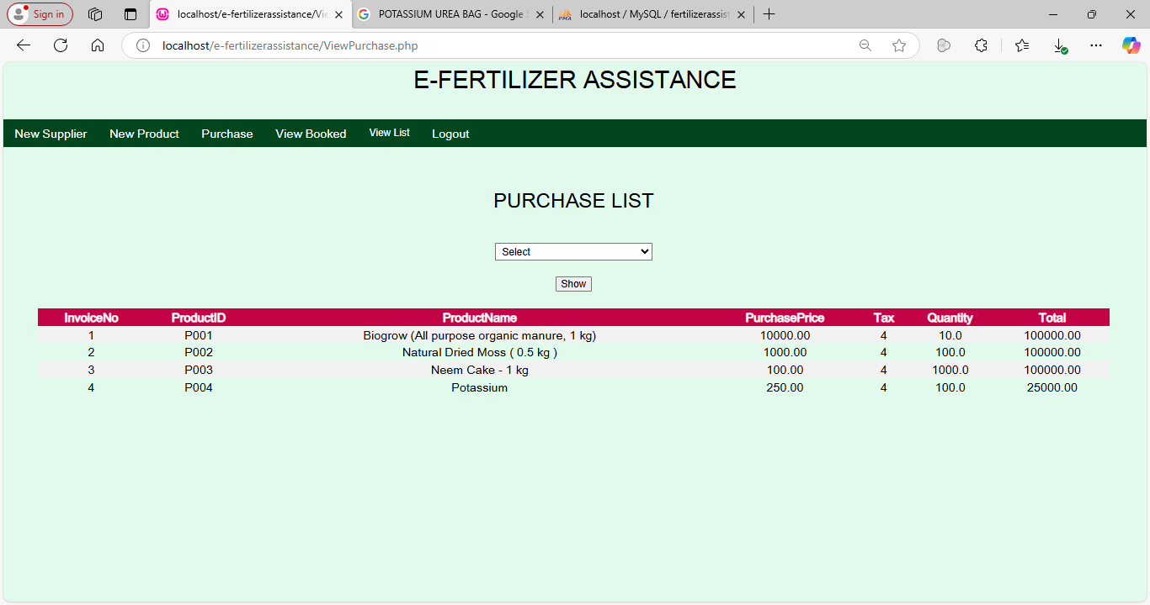
VIEW DELIVERED

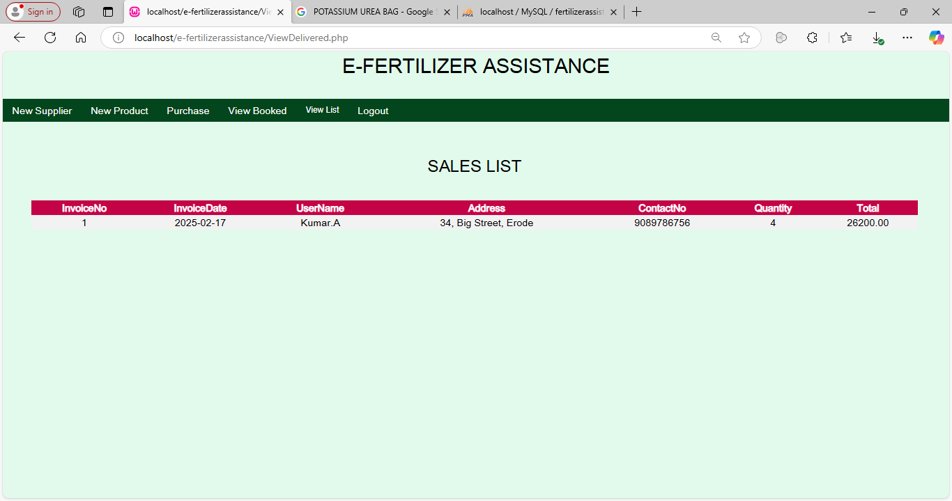
VIEW QUERIES
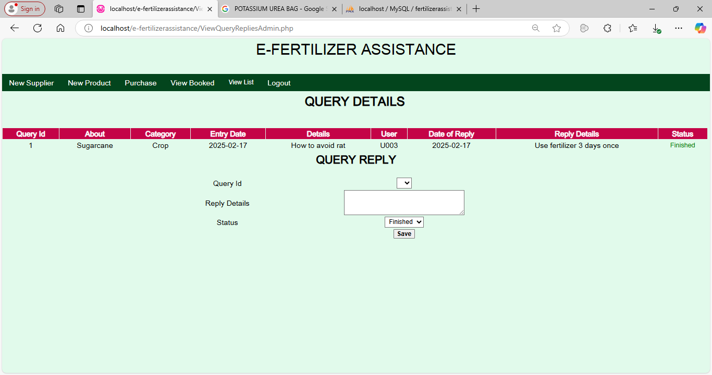
FARMER REGISTRATION

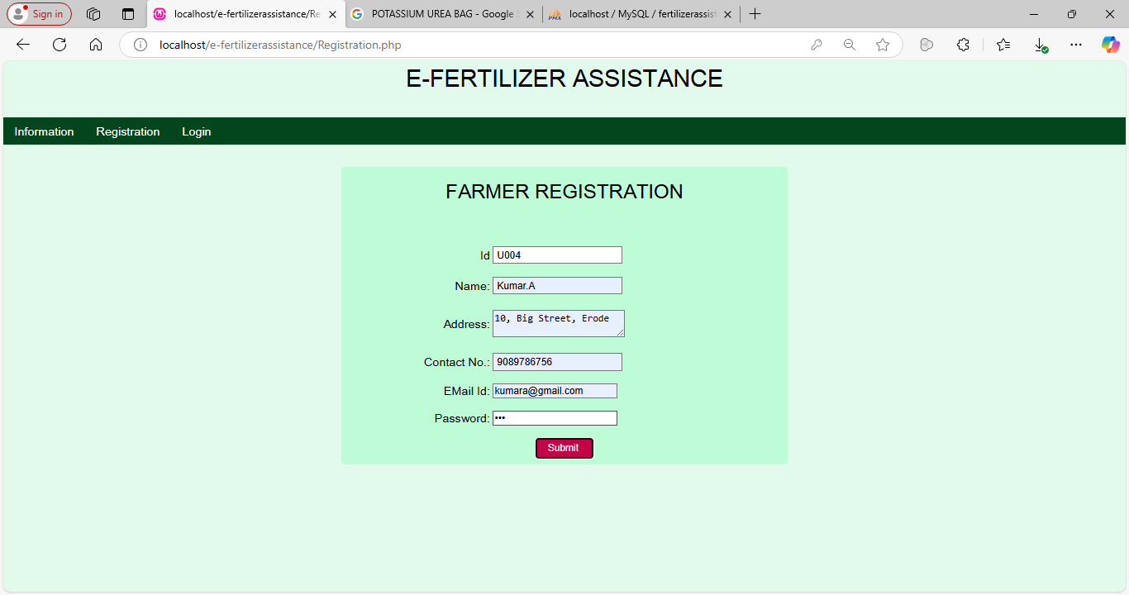
USER LOGIN
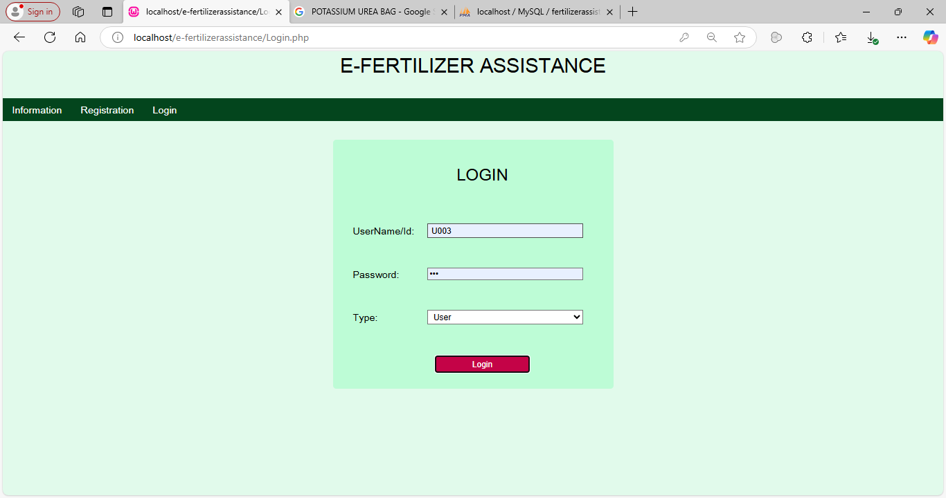
VIEW ITEMS
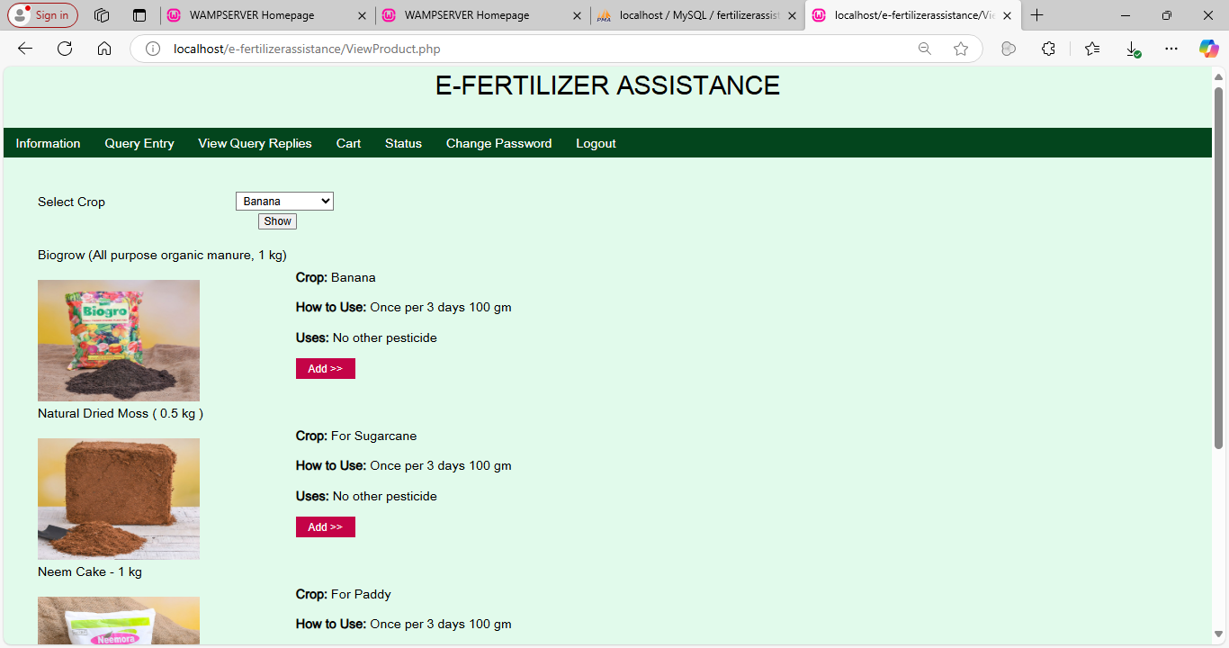
NEW QUERY ENTRY
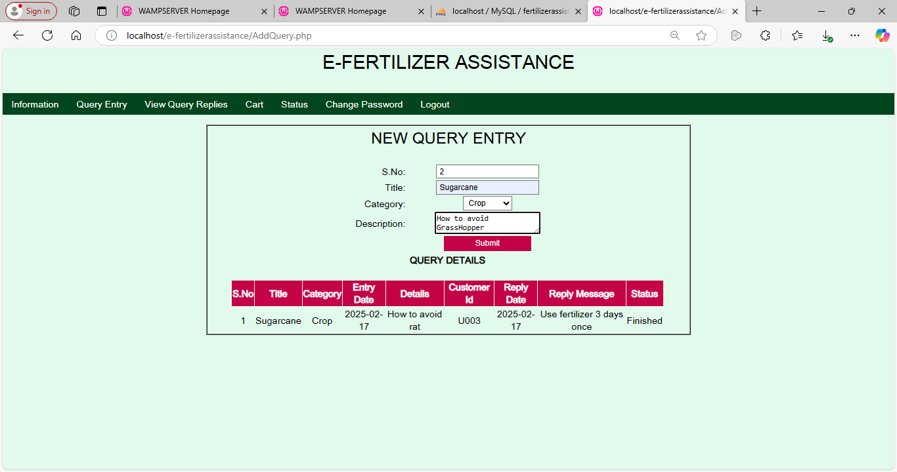
VIEW QUERIES
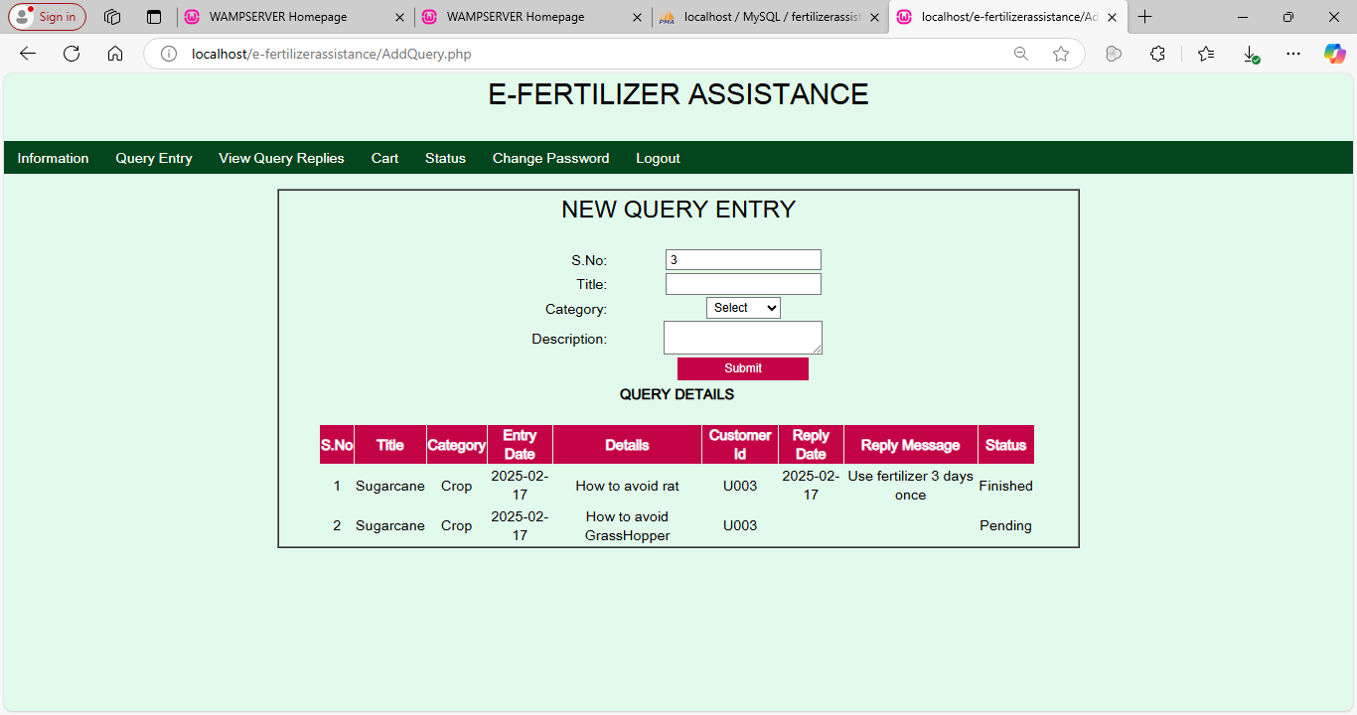
VIEW QUERY REPLIES
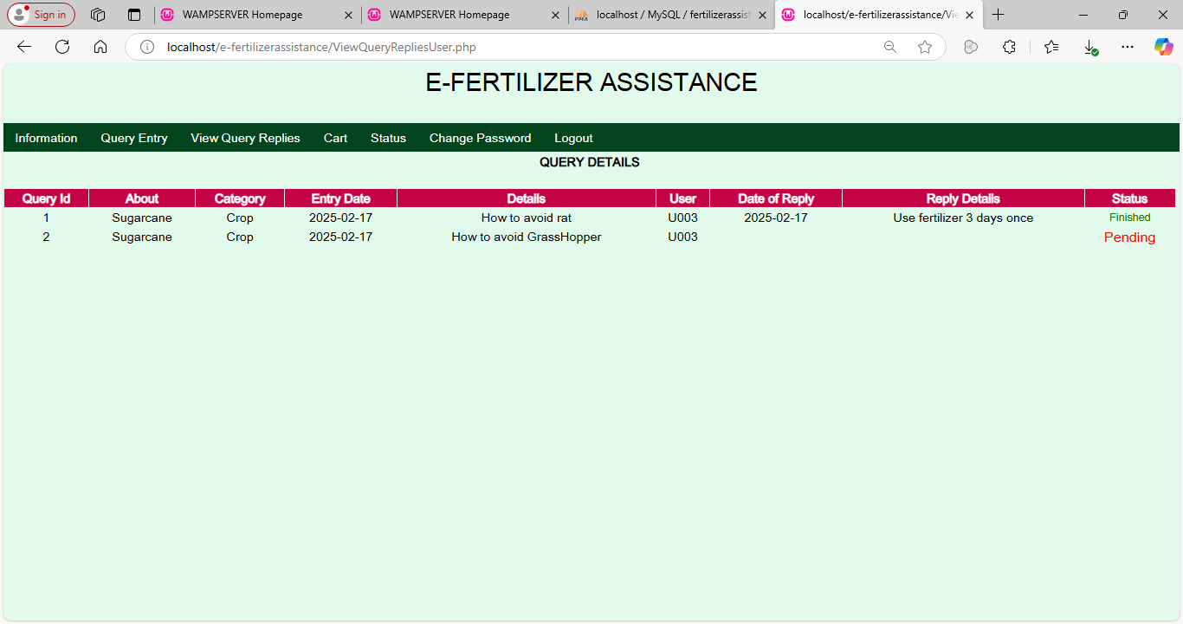
VIEW CART
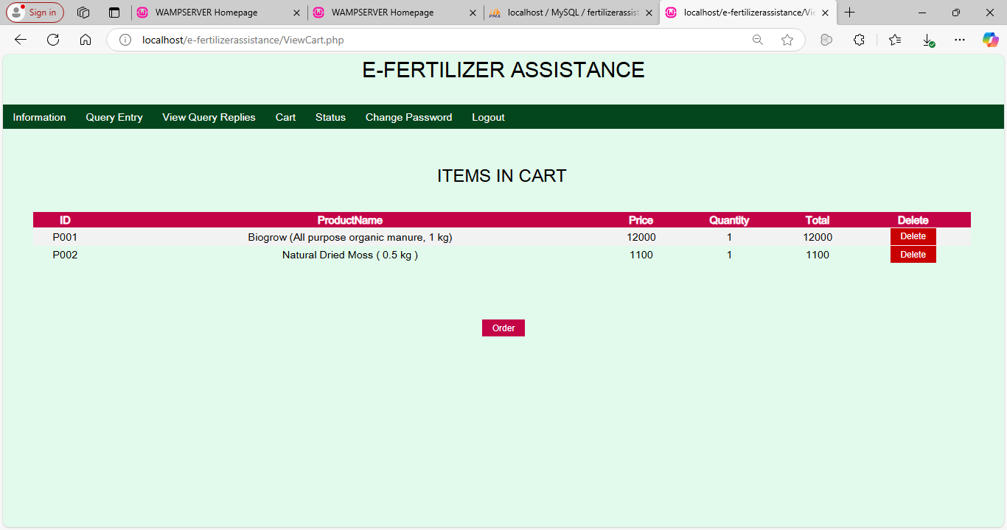
VIEW ORDER STATUS
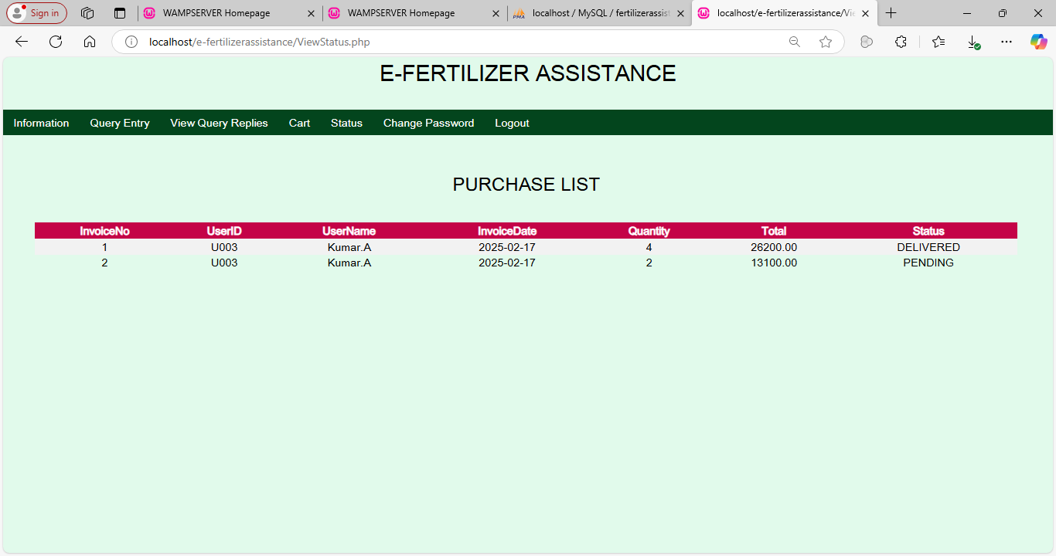
CHANGE PASSWORD
